Certified Professional Ethical Hacker
KEY DATA

Course Title: Certified Professional Ethical Hacker
Duration: 5 Days
Language: English
Class Format Options:
Instructor-led classroom
Live Online Training
Prerequisites:
- 12 months of IT security experience
- 12 months of Networking Experience
Student Materials:
- Student Workbook
- Student Lab guide
- Exam Prep Guide

CPEs: 40

WHO SHOULD ATTEND?

- Information System Owners
- Security Officers
- Ethical Hackers
- Information Owners
- Penetration Testers
- System Owner and Managers
- Cyber Security Engineers

COURSE BENEFITS
Pen Testing Career

The Certified Professional Ethical Hacker vendor neutral certification course is the foundational training to mile2’s line of penetration testing courses.

The CPEH certification training enables students to understand the importance of vulnerability assessments by providing industry knowledge and skills in Vulnerability Assessments. In doing so, the CPEH student is able to understand how malware and destructive viruses function. In addition, the CPEH course helps students learn how to implement counter response and preventative measures when it comes to a network hack.

The CPEH course provides in-depth labs that focus on both open source and commercial based tools with industry best practices. These hands on labs emulate real world hacking scenarios and equip the candidate to assess your company’s security posture, help implement controls to better secure your company’s network infrastructure and how to combat against hackers and/or viruses, etc.

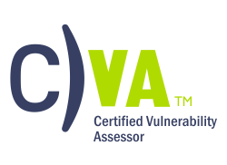

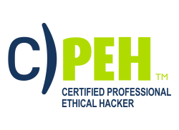
*

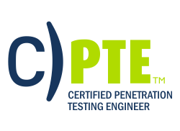

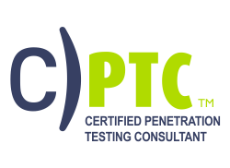

All Combos Include:
- Online Video
- Electronic Book (Workbook/Lab guide)
- Exam Prep Questions
- Exam
- Cyber Range Lab

ACCREDITATIONS
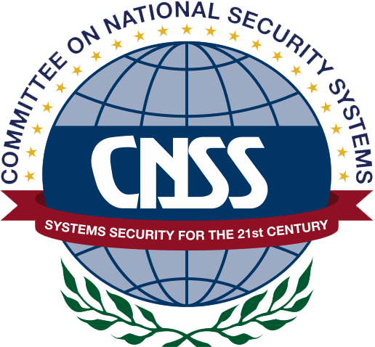
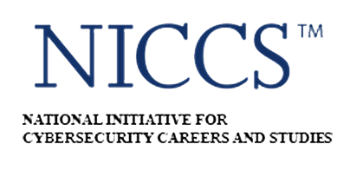


UPON COMPLETION
Upon completion, the Certified Professional Ethical Hacker candidate will be able to competently take the CPEH exam.
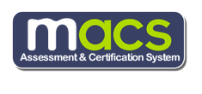
EXAM INFORMATION
The Certified Professional Ethical Hacker exam is taken online through Mile2’s Assessment and Certification System (“MACS”), which is accessible on your mile2.com account. The exam will take 2 hours and consist of 100 multiple-choice questions. The cost is $400 USD and must be purchased from Mile2.com.
OUTLINE
Module 0 – Course Introduction
Module 1 – Introduction to Ethical Hacking
Module 2 – Linux Fundamentals
Module 3 – Protocols
Module 4 - Cryptography
Module 5 - Password Cracking
Module 6 - Malware
Module 7 – Security Devices
Module 8 – Information Gathering - Passive Reconnaissance
Module 9 – Social Engineering
Module 10 – Active Reconnaissance
Module 11 – Vulnerability Assessment
Module 12 – Network Attacks
Module 13 – Hacking Servers
Module 14 – Hacking Web Technologies
Module 15 - Hacking Wireless Technologies
Module 16 – Maintaining Access and Covering Tracks

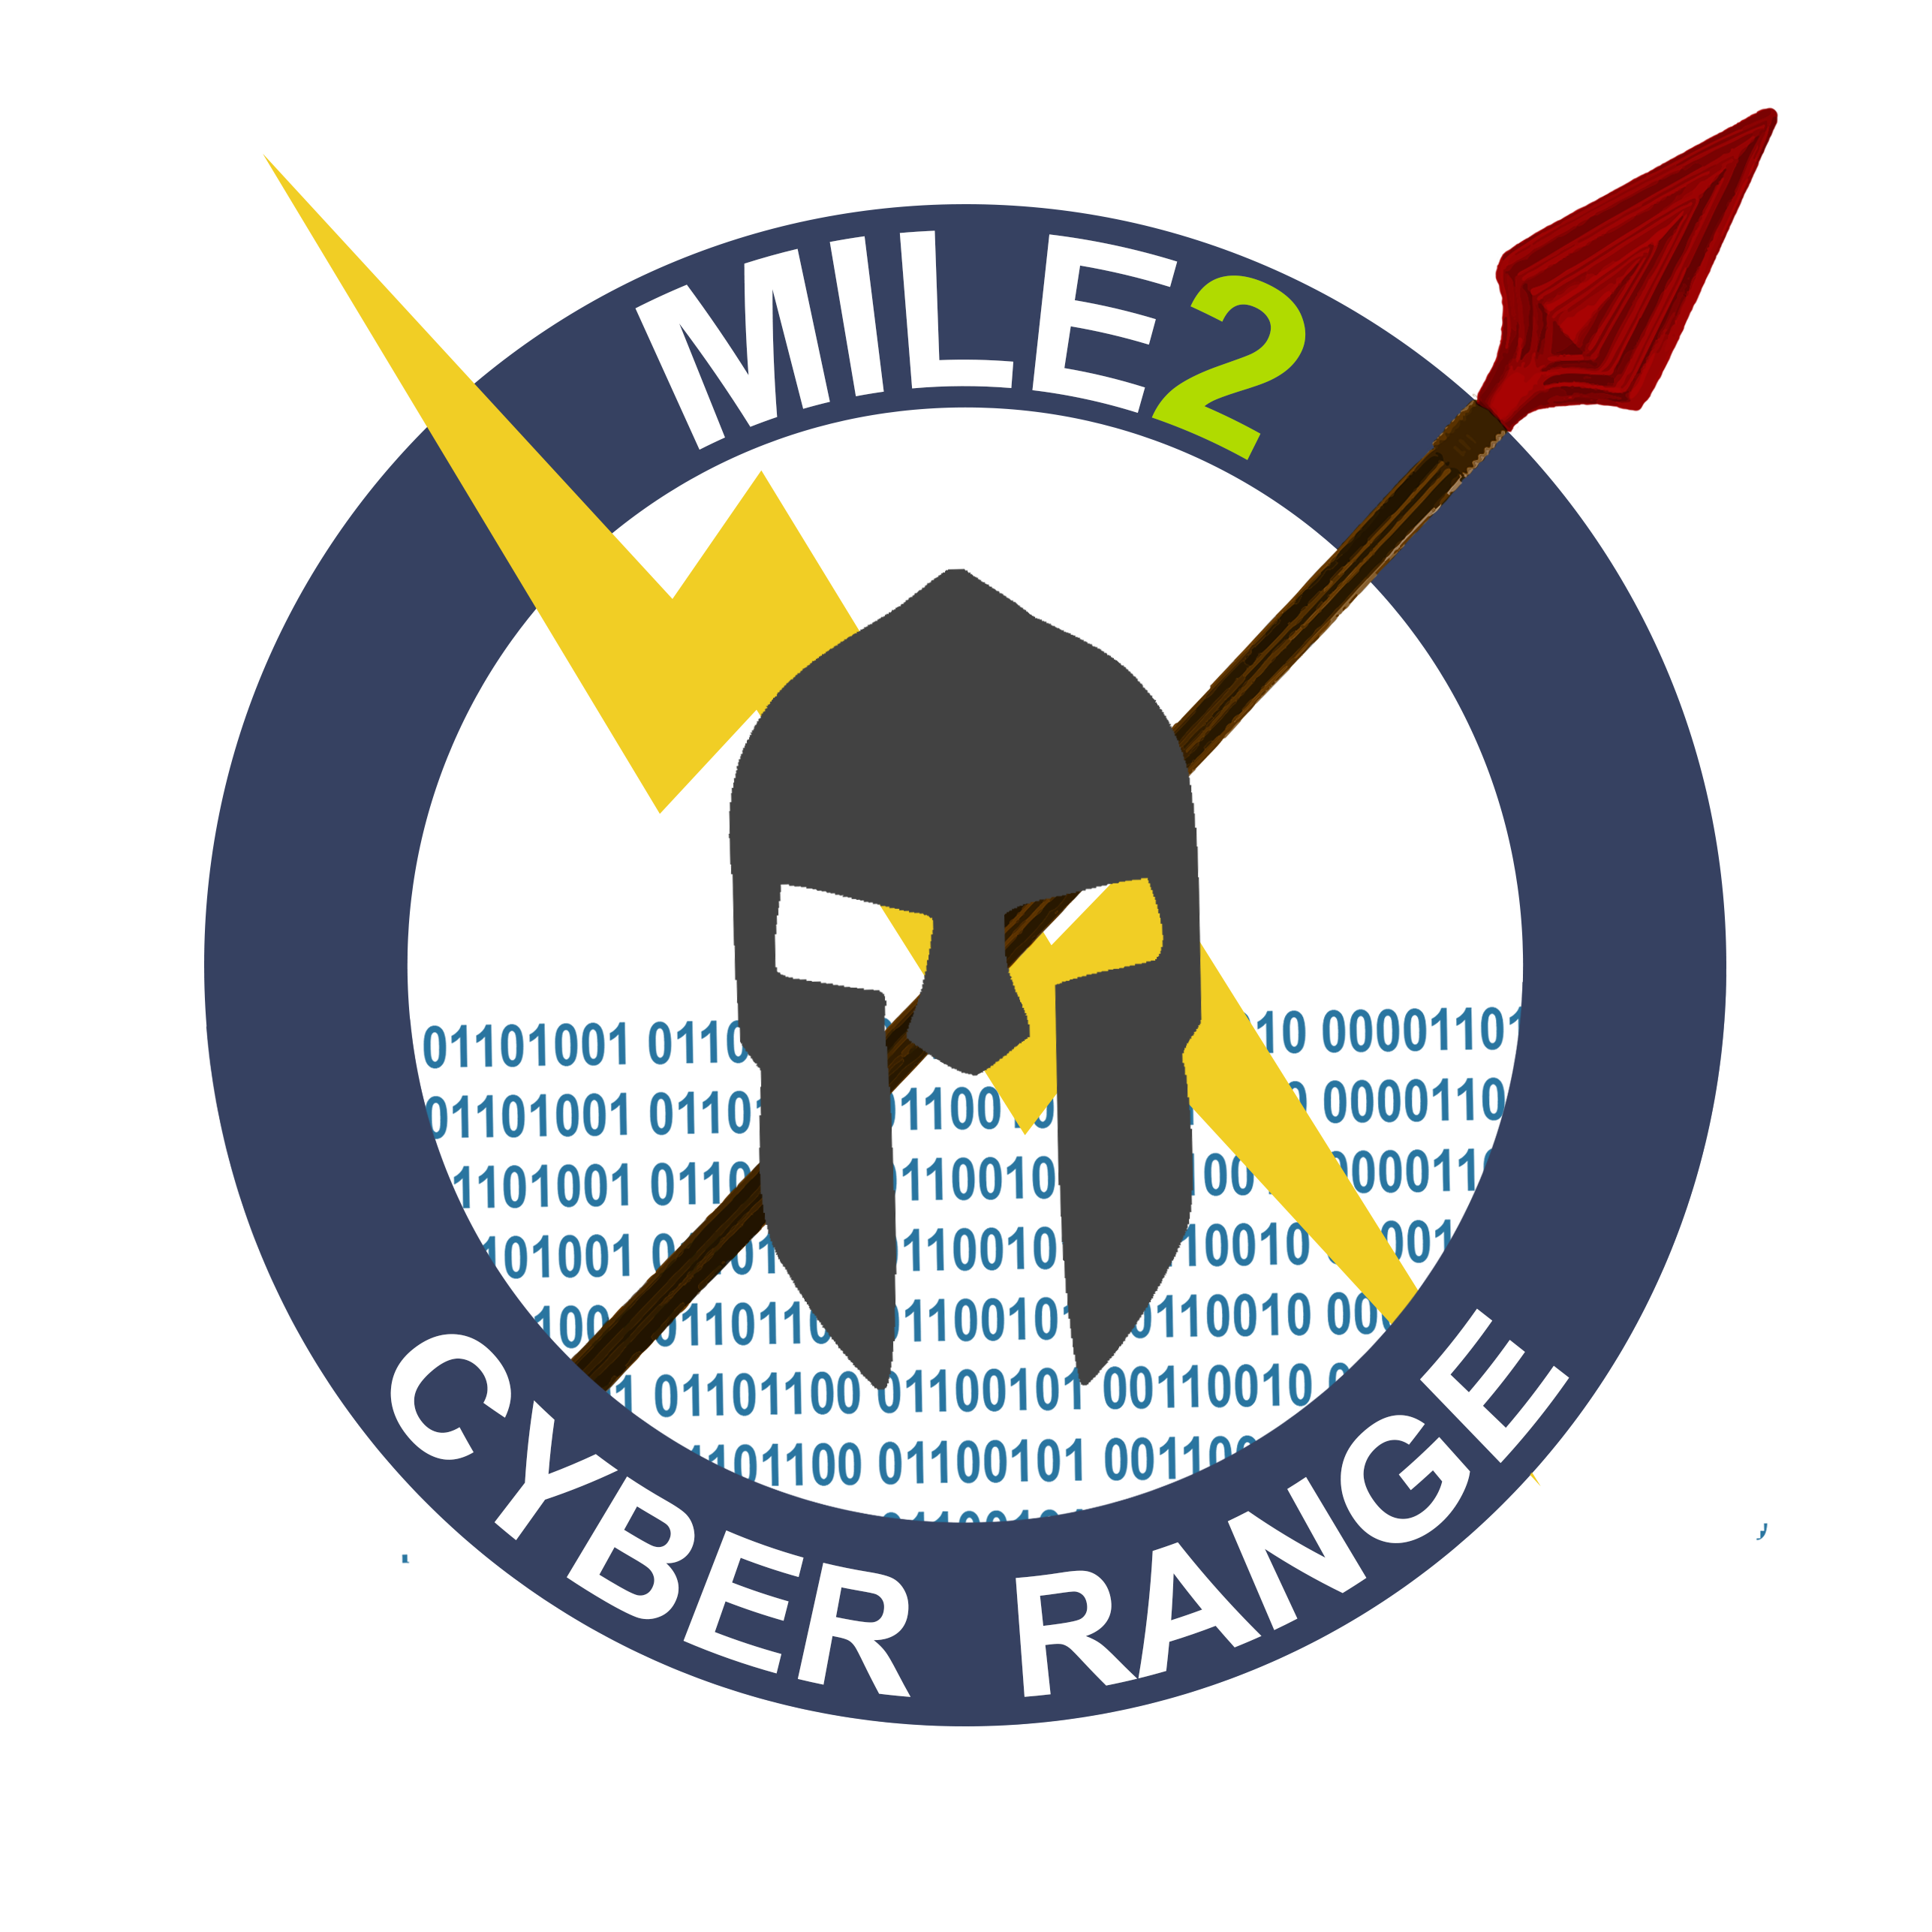
LAB OUTLINE

Lab 1 – Intro to C)PEH Setup
Lab 2 - Linux Fundamentals
Lab 3 – Understanding Protocols
Lab 4 - Cryptography Lab
Lab 5 – Password Cracking
Lab 6 - Malware
Lab 7 – Information Gathering
Lab 8 – Vulnerability Assessment
Lab 9 – Network Sniffing/IDS
Lab 10 - Windows Hacking
Lab 11 – Attacking Databases
Lab 12 – Attacking Web Applications
Lab 13 - Backdoors

