Certified Security Principles
KEY DATA

Course Name: Certified Security Principles

Duration: 5 Days

Language: English

Format
Instructor Led Training
Instructor Led Online Training

Prerequisites:
Participants should possess basic Windows user skills and a fundamental understanding of computer and networking concepts.

Student Materials:
Student Workbook

Certification Exams:
Certified Security Principles
Covers Security+ Exam Objectives

CEUs: 40
WHO SHOULD ATTEND?
IT professionals with networking and administrative skills in Windows®-based Transmission Control Protocol/Internet Protocol (TCP/IP) networks and is familiar with other operating systems (Linux, etc.)

COURSE OVERVIEW

Mile2’s Certified Security Principles course provides the skills necessary to apply and implement technical knowledge of security concepts in today’s security environment. Students will gain an in‐depth knowledge of systems security, access control, network infrastructure, assessments and audits, cryptography and organizational security across all vendor products. These skills have become increasingly important, as additional safeguards such as intrusion detection systems, physical access control and multi‐factor authentication become standard methods of protection. Students are given real world scenarios to reinforce the material covered and will learn how to apply the concepts to their daily operations.

COURSE OBJECTIVES
- Identify the fundamental concepts of computer security.
- Identify security threats and vulnerabilities.
- Manage data, application, and host security.
- Implement network security.
- Identify and implement access control and account management security measures.
- Manage certificates.
- Identify and implement compliance and operational security measures.
- Manage risk.
- Troubleshoot and manage security incidents.
- Plan for business continuity and disaster recovery.

Career
Fundamental



All combos Include:
- Online Video
- Electronic Book (Workbook/Lab guide*)*in technical classes only
- Exam Prep Questions
- Exam

ACCREDITATIONS

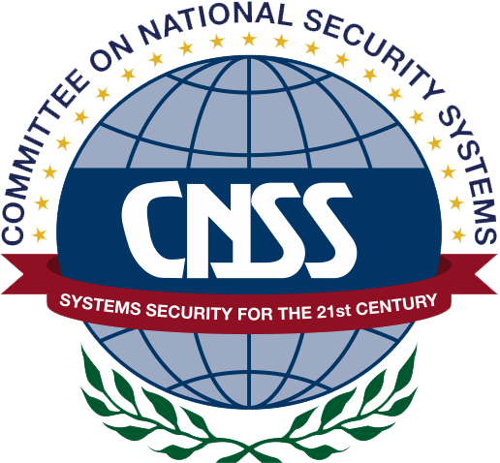


UPON COMPLETION
Upon completion, the Certified Security Principles candidate will not only be able to competently take the CSS exam but will also understand basic cyber security knowledge to keep companies’ IP and IT infrastructure safe.
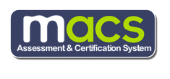
EXAM INFORMATION
The Certified Security Principles exam is taken online through Mile2’s Assessment and Certification System (“MACS”), which is accessible on your mile2.com account. The exam will take 2 hours and consist of 100 multiple choice questions. The cost is $400 USD and must be purchased from Mile2.com.
OUTLINE
Module 1 - Threats and Vulnerabilities
Module 2 - Cryptography
Module 3 - Identity and Access Control
Module 4 - Network Security
Module 5 - Host/Server Security
Module 6 - Data Security
Module 7 - Application Security
Module 8 - Mobile Security
Module 9 - Compliance and Operational Security

COURSE DETAILS

Module 1 - Threats and Vulnerabilities
  - Types of Malware
  - Types of Attacks
  - Social Engineering
  - Mitigating Attacks
  - Discovering vulnerabilities and threats
  - Vulnerability Assessment and Penetration Testing
Module 2 - Cryptography
  - Understanding crypto concepts
  - Crypto methods and where to use them
  - PKI and Certificate Management
Module 3 - Identity and Access Control
  - Why IAM?
  - Various Authentication Services
  - AAA
  - Implementing the Controls
Module 4 - Network Security
  - Network Devices
  - Other Devices
  - Administering and Implementing Security
  - Network Design
  - Protocols and Services
  - Wireless Networking
Module 5 - Host/Server Security
  - The Operating Systems
  - Hardening the OS
  - OS additional software security
  - Physical security

Module 6 - Data Security
  - Different Types of Storage
  - Risks associated with all types of storage
  - Encryption Options
  - Corporate Management Options
  - Various device uses
  - Hardware security options for storage
Module 7 - Application Security
  - Application Security Principals
  - Secure Coding Concepts
  - Hacking for the purpose of testing
  - Top 10 OWASP Risks
  - How to harden against those risks
  - Patch Management
Module 8 - Mobile Security
  - What devices are we talking about?
  - The Risk
  - Hardening these Devices!
  - Corporate Management and Legal issues
Module 9 - Compliance and Operational Security
  - Managing Risk
  - Managing Risk with third parties
  - Implementing Corporate Strategies
  - Incident Response and Forensics Procedures
  - Utilizing Physical and Environmental Controls

