Course Name: Certified Secure Web Application Engineer
Duration: 4 days
Format:
Instructor-led
Live Virtual Training
Prerequisites:
- A minimum of 24 months’ experience in software technologies & security
- Sound knowledge of networking
- At least one coding Language
- Linux understanding
- Open shell
Student Materials:
- Student Workbook
- Student Lab Guide
- Exam prep guide
Certification Exam:
Mile2’s CSWAE- Certified Secure Web Application Engineer

CPEs: 32 Hours

WHO SHOULD ATTEND?
- Coders
- Web Application Engineers
- IS Managers
- Application Engineers
- Developers
- Programmers
Organizations and governments fall victim to internet based attacks every day. In many cases, web attacks could be thwarted but hackers, organized criminal gangs, and foreign agents are able to exploit weaknesses in web applications. The Secure Web programmer knows how to identify, mitigate and defend against all attacks through designing and building systems that are resistant to failure. The secure web application developer knows how to develop web applications that aren’t subject to common vulnerabilities, and how to test and validate that their applications are secure, reliable and resistant to attack. The vendor neutral Certified Secure Web Application Engineer certification provides the developer with a thorough and broad understanding of secure application concepts, principles and standards. The student will be able to design, develop and test web applications that will provide reliable web services that meet functional business requirements and satisfy compliance and assurance needs.
The Certified Secure Web Application Engineer course is delivered by high level OWASP experts and students can expect to obtain real world security knowledge that enables them to recognize vulnerabilities, exploit system weaknesses and help safeguard against application threats.

UPON COMPLETION
Upon completion, Certified Secure Web Application Engineer students will be able to establish industry acceptable auditing standards with current best practices and policies. Students will also be prepared to competently take the C)SWAE exam.

EXAM INFORMATION
The Certified Secure Web Application Engineer exam is taken online through Mile2’s Assessment and Certification System (“MACS”), which is accessible on your mile2.com account. The exam will take 2 hours and consist of 100 multiple choice questions. The cost is $400 USD and must be purchased from Mile2.com.
COURSE CONTENT
Module 1: Web Application Security
Module 2: OWASP TOP 10
Module 3: Threat Modeling & Risk Management
Module 4: Application Mapping
Module 5: Authentication and Authorisation attacks
Module 6: Session Management attacks
Module 7: Application Logic attacks
Module 8: Data Validation
Module 9: AJAX attacks
Module 10: Code Review and Security Testing
Module 11: Web Application Penetration Testing
Module 12: Secure SDLC
Module 13: Cryptography
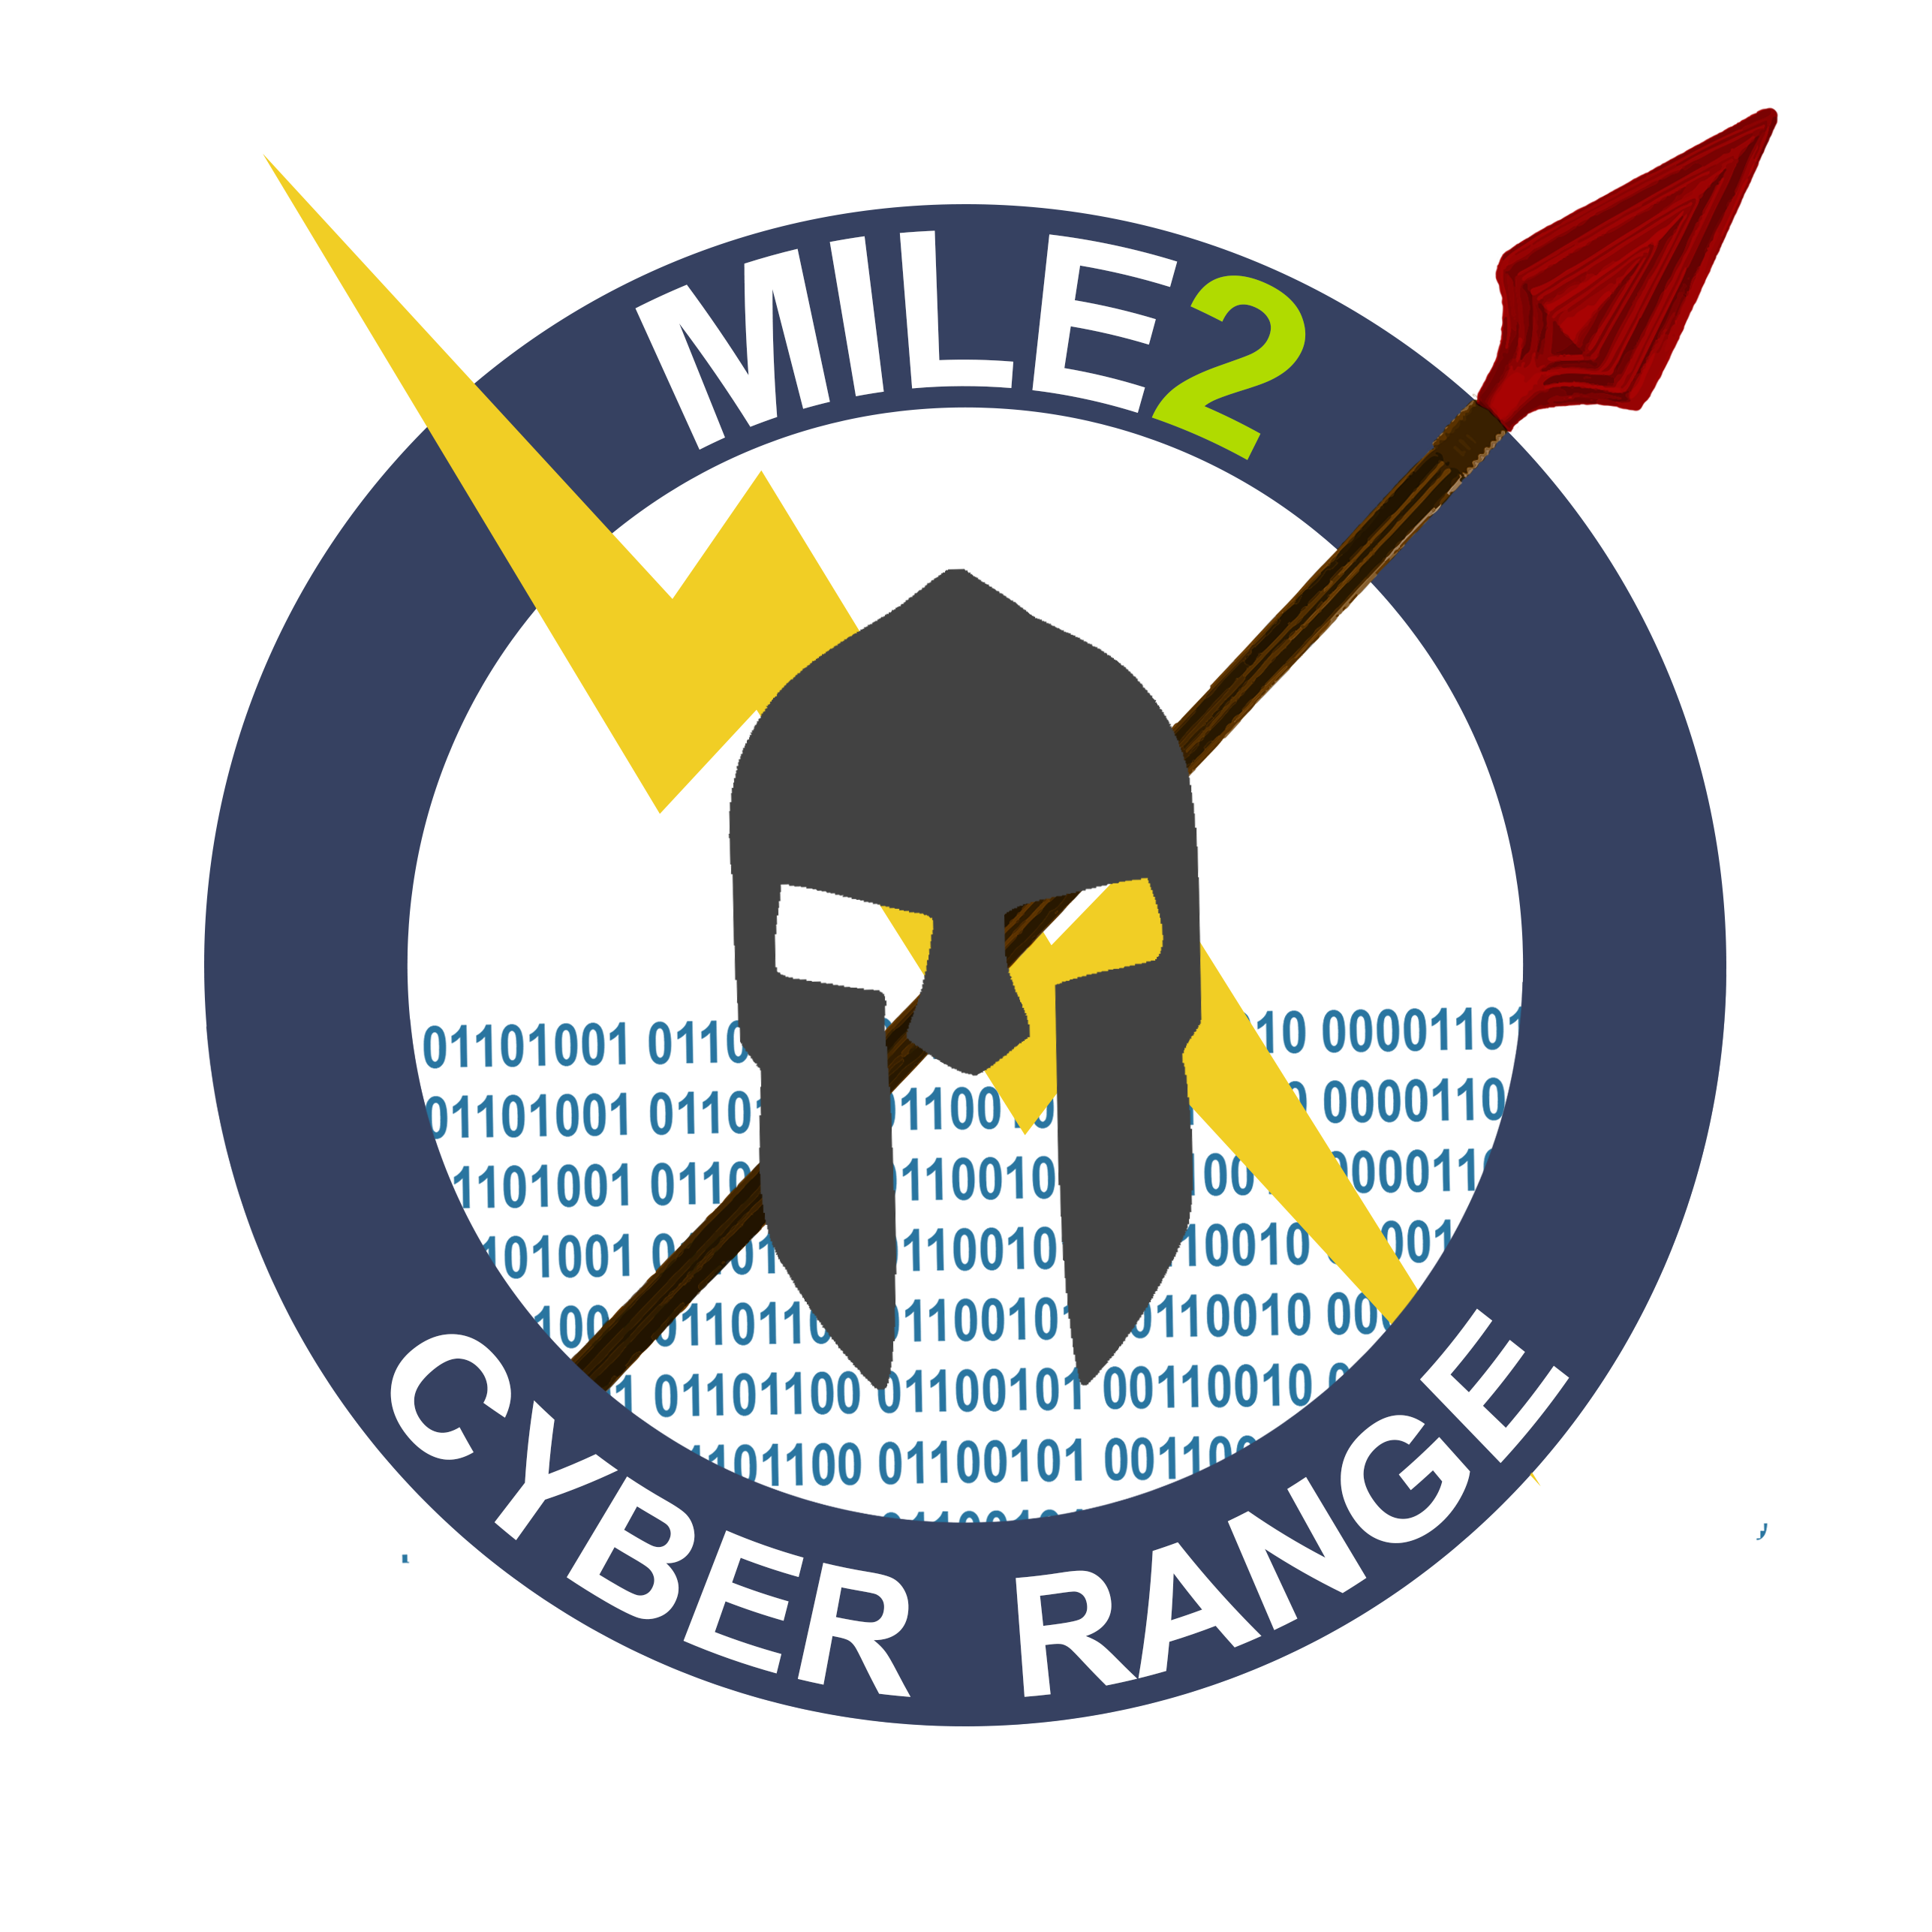
LAB CONTENT

Module 04 – Application Mapping & Analysis
Module 5 – Authentication and Authorization attacks
Module 06 - Session Management attacks
Module 9 – AJAX Security
Module 10 – Code Review and Security Testing
Lab 10-1 – Code Review
Lab 10-2 Security Test Scripts
Lab 10-3 Writing Java Secure Code
Annex 11: Alternatives Labs
Lab 11-1: WebGoat & Webscarab
Lab 11-2: WebGoat - Cross Site Request Forgery (CSRF)
Lab 11-3: Missing Function Level Access Control
Lab 11-4: Perform Forced Browsing Attacks
Module 1 – Environment Setup and Architecture
Module 2 – OWASP TOP 10 2013
Module 3 – Threat Modeling

DETAILED OUTLINE

Module 1: Web Application Security
Web Application Security
Web Application Technologies and Architecture
Secure Design Architecture
Application Flaws and Defense Mechanisms
Defense In-Depth
Secure Coding Principles
Module 2: OWASP TOP 10
The Open Web Application Security Project (OWASP)
OWASP TOP 10 2013
Module 3: Threat Modeling & Risk Management
Threat Modeling Tools & Resources
Identify Threats
Identify Countermeasures
Choosing a Methodology
Post Threat Modeling
Analyzing and Managing Risk Incremental Threat Modeling
Identify Security Requirements
Understand the System
Root Cause Analysis
Module 4: Application Mapping
Application Mapping
Web Spiders
Web Vulnerability Assessment
Discovering other content
Application Analysis
Application Security Toolbox
Setting up a Testing Environment

Module 5: Authentication and Authorization attacks
Authentication
Different Types of Authentication (HTTP, Form)
Client Side Attacks
Authentication Attacks
Authorization
Modeling Authorization
Least Privilege
Access Control
Authorization Attacks
Access Control Attacks
User Management
Password Storage
User Names
Account Lockout
Passwords
Password Reset
Client-Side Security
Anti-Tampering Measures
Code Obfuscation
Anti-Debugging
Module 6: Session Management attacks
Session Management Attacks
Session Hijacking
Session Fixation
Environment Configuration Attacks
Module 7: Application Logic attacks
Application Logic Attacks
Information Disclosure Exploits
Data Transmission Attacks

Module 8: Data Validation
Input and Output Validation
Trust Boundaries
Common Data Validation Attacks
Data Validation Design
Validating Non-Textual Data
Validation Strategies & Tactics
Errors & Exception Handling
Structured Exception Handling
Designing for Failure
Designing Error Messages
Failing Securely
Module 9: AJAX attacks
AJAX Attacks
Web Services Attacks
Application Server Attacks
Module 10: Code Review and Security Testing
Insecure Code Discovery and Mitigation
Testing Methodology
Client Side Testing
Session Management Testing
Developing Security Testing Scripts
Pen testing a Web Application
Module 11: Web Application Penetration Testing
Insecure Code Discovery and Mitigation
Benefits of a Penetration Test
Current Problems in WAPT
Learning Attack Methods

Methods of Obtaining Information
Passive vs. Active Reconnaissance
Footprinting Defined
Introduction to Port Scanning
OS Fingerprinting
Web Application Penetration Methodologies
The Anatomy of a Web Application Attack
Fuzzers
Module 12: Secure SDLC
Secure-Software Development Lifecycle (SDLC) Methodology
Web Hacking Methodology

Module 13: Cryptography
Overview of Cryptography
Key Management
Cryptography Application
True Random Generators (TRNG)
Symmetric/Asymmetric Cryptography
Digital Signatures and Certificates
Hashing Algorithms
XML Encryption and Digital Signatures Authorization Attacks
NOTE: Student will use Kali Linux

DETAILED LAB DESCRIPTION
Module 1 – Environment Setup and Architecture
Exercise 1 – VM Image Preparation
Exercise 2 – Checking Network connectivity between all VMs
Exercise 3 – Discovering your class share (Optional, ask the Instructor)
Exercise 4 – Navigating Linux Attack v3
Exercise 5 – Proxy Setup - Setting up Burp Suite
Exercise 6 – Setting up Paros
Exercise 7 – Setting up WebScrab
Module 2 – OWASP TOP 10 2013
Exercise 1- Injection Flaws - SQL Injection (AltoroMutual banking site)
Exercise 2- Injection Flaws – String SQL Injection (OWASP Broken Apps WebGoat)
Exercise 3- Cross Site Scripting (XSS)
Exercise 4 - Cross Site Request Forgery (CSRF)
Module 3 – Threat Modeling
Exercise 1 – Application Risk Assessment
Exercise 2: Define the Entry Points
Exercise 3: Define the Assets
Exercise 4: Define User Access
Exercise 5: Identify and Rate Risks
Exercise 6: Identify Security Controls
Exercise 7: Identify Threats
Module 04 – Application Mapping & Analysis
Exercise 1 - Enumerating Content and Functionality
Exercise 2 - User-Directed Spidering
Exercise 3 - Discovering hidden content
Exercise 4 - Brute-Force Techniques brute force DVWA
a. Form Based Authentication
b. Attacking Web Authentication
Module 5 – Authentication and Authorization attacks
Exercise 1 - Missing Function Level Access Control
Exercise 2 - Sensitive Data Exposure
Exercise 3 - Security Misconfiguration
Exercise 4 - Using Components with Known Vulnerabilities
Module 06 - Session Management attacks
Exercise 1 - Hijack a Session

Exercise 2 - Spoof an Authentication Cookie
Exercise 3 - Session Fixation
Exercise 4 - Broken Authentication and Session Management (AltoroMutual banking)
Module 9 – AJAX Security
Exercise 1: Same Origin Policy Protection
Exercise 2: DOM-Based cross-site scripting
Exercise 3: Client Side Filtering
Module 10 – Code Review and Security Testing
Lab 10-1 – Code Review
Exercise 1: Account Retriever
Exercise 2: FileUpload
Exercise 3: XMLHelper
Lab 10-2 Security Test Scripts
Exercise 1: Create Test Scripts
Lab 10-3 Writing Java Secure Code
Annex: Alternatives Labs
Lab 11-1: WebGoat & WebScarab
Exercise 11-1.1: Logging into WebGoat
Exercise 11-1.2: Running WebScarab
Exercise 11-1.3: Manipulating Data
Lab 11-2: WebGoat - Cross Site Request Forgery (CSRF)
Lab 11-3: Missing Function Level Access Control
Lab 11-4: Perform Forced Browsing Attacks

